Title: “Columbia Chemical Engineering Fuel Cell Car Demonstration and Competition”
Authors
Christianna Lininger, Ph.D. Candidate, Department of Chemical Engineering Columbia University in the City of New York, 10027, cnl2117@Columbia.edu, 212-854-4546
Anna Dorfi, Ph.D. Candidate, Department of Chemical Engineering Columbia University in the City of New York, 10027, aed2151@Columbia.edu, 212-854-4546
Robert G. Bozic, Ph.D. Lieutenant Colonel U.S. Army(Retired), Lecturer in Chemical Engineering Design and Chemical Engineering Process Safety, Department of Chemical Engineering Columbia University in the City of New York, 10027, robert.bozic@Columbia.edu, 212-854-9637. Corresponding Author.

Abstract:
The first Columbia Chemical Engineering Fuel Cell Car Demonstration and Competition was planned, developed, and executed in order to inspire and educate young people about chemical engineering. This hands-on experience was modelled after the American Institute of Chemical Engineers (AIChE) ChemE Car Competition using the X7 Fuel Cell Car from Thames and Kosmos. [1, 2] This competition was part of a Science Technology Engineering and Math (STEM) outreach event organized by the Chemical Engineering Graduate Organization (ChEGO) and Dr. Robert G. Bozic, Lieutenant Colonel U.S. Army(Retired) in the Columbia University Department of Chemical Engineering. The concept for the event and lessons learned are shared in order to promote the fuel cell car demonstration and competition as a chemical engineering STEM outreach event.
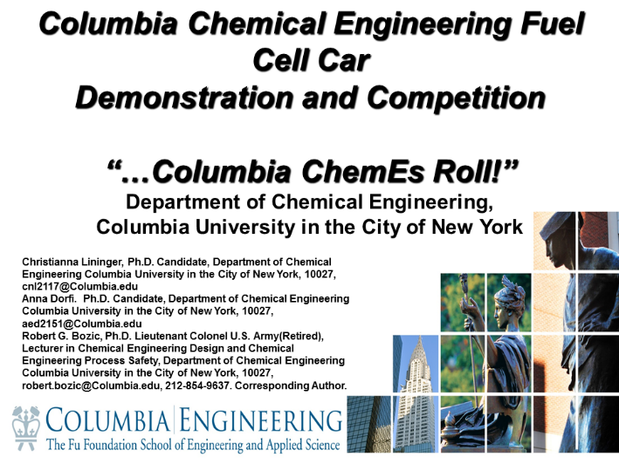
Paper:
The first Columbia Chemical Engineering Fuel Cell Car Demonstration and Competition was planned, developed, and executed in order to inspire and educate young people about chemical engineering. This hands-on experience was modelled after the American Institute of Chemical Engineers (AIChE) ChemE Car Competition using the X7 Fuel Cell Car from Thames and Kosmos. This competition was part of a Science Technology Engineering and Math (STEM) outreach event organized by the Chemical Engineering Graduate Organization (ChEGO) and Dr. Robert G. Bozic, Lieutenant Colonel U.S. Army(Retired) in the Columbia University Department of Chemical Engineering. The purpose of this event was to enable high school student involvement in a competitive chemical engineering experience built on the foundations of the American Institute of Chemical Engineers (AIChE) ChemE Car competition, with easily manageable logistics and short preparation times, while meeting all safely requirements. In order to meet these challenges in a time constrained environment, ten of the Thames and Kosmos X7 fuel cell cars affectionately named after the Columbia themes (Roar-ee, Pride, Lion, Lioness, Cub, and Ivy) and electrochemical engineering themes (ChemE, Electro, Voltaic, and Galvanic) were used in graduate student led competition. Over 30 students and visitors were introduced to this unique chemical engineering competition concept and encouraged to participate at increasing levels of complexity.
Two levels of competition are available, “Speed Racer” and “Chemical Engineer”. The “Speed Racer” level includes brief instruction on risk assessment, chemical safety, principles of the mass and energy balance, and emphasis on the chemical engineering nature of the competition as well as emphasis on the engineer problem solving approach. This level allows for the student to reach the trial run stage within minutes. The “Chemical Engineer” level emphasizes the basics seen in the “Speed Racer” level as well as error analysis, computer aided design using ASPEN, efficiency calculations, and a more deliberate approach to understanding effects of error on the equations used to estimate the volume of hydrogen gas required to travel the desired distance. The time scales would be in hours, for a thorough treatment of the areas of emphasis in the “Chemical Engineer” level. The essence of the competition is to determine the volume required in order to make the X7 Fuel Cell Car move the distance desired and to achieve success by being the team that gets the car as closest to the finish line as possible without touching the finish line or going over it with any part of the car. [3] Presented with this chemical engineering problem, the student competitors with the assistance of a graduate student leaders are fully engaged in a chemical engineering competition that may be executed indoors or out. Based on inclement weather decisions associated with outdoor activity, generally the competition has been conducted indoors. The purpose of this article is to outline the event as a means for others to replicate the type of Chemical Engineering STEM Outreach conducted at Columbia University Department of Chemical Engineering. The event is broken down into phases, Planning and Resourcing, Instructor Preparation and Rehearsals, ChemE Fuel Cell Car Demonstration and Competition, Recovery Operations, and After Action Review. Some conclusions are presented as well.
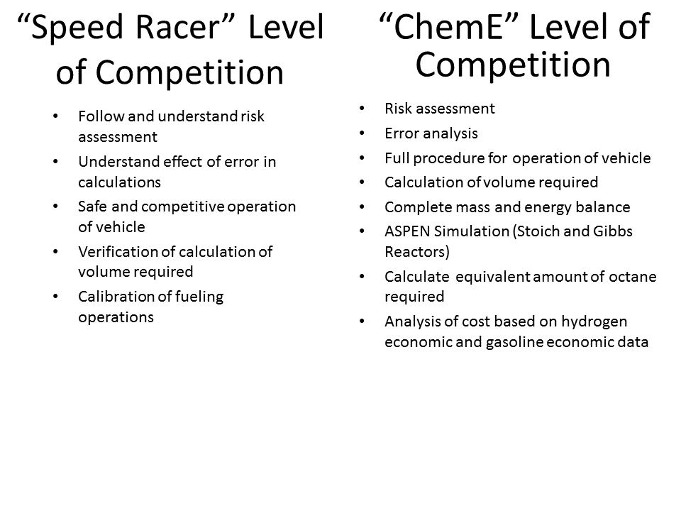
Planning and Resourcing
The first stage in preparation for the event is planning and resourcing. The planning cycle before the event was driven by the availability of the graduate student leaders, faculty, and student competitors. Much of the planning and resourcing for the event was done by the instructor based on previous experience as a faculty advisor to the West Point Chemical Engineering Club[3]. The graduate students coordinated with a local school and the engineering school for the interested students and the event space respectively. The graduate students were in charge of synchronizing schedules. An inherent understanding of the event was needed in order to lead it.
Based on previous experience with student groups, a resource list was developed and is enclosed in appendix 1. A set of 10 cars was purchased to support roughly three students per group. Stickers were printed using Avery “White Easy Peel” Address Labels (#5160) for each member of the competitive student group in order to promote team unity.[4] The stickers were also placed on the cars so that the students could readily identify their car. Duct tape was purchased for marking the start line and the finish line as well as the side lines so that the competition zone was fully designated. Two measuring tapes were purchased for use when measuring the distance from the finish line to the car. Volt meters were purchased in order to check the voltage on batteries and on the fuel cells in order to help with trouble shooting and with instruction of student groups. Group names were printed in color and placed in document protectors in the vicinity of each group’s filling station area. Start line, finish line, competitive zone and filling station signs were also printed and placed on display in order to mark the competition areas. AA batteries are needed for each battery pack that comes with the X7 kit. The battery pack covers were removed from each battery pack as it is another small piece of plastic that is easily lost and based on safety and best practices it is best to minimize the time the batteries are in the charging packs. Removal of the cover makes it easier to remove the batteries. The batteries will overheat and degrade if they are not taken out of the battery pack. The parachute cord was purchased and had been used as lane marker in some trials. For this trial the cord that was purchased blended in too well with the carpet. The tape sufficed a lane marker. If cord is used, a bright color is recommended and care must be taken not to create a tripping hazard. The cord is helpful for hanging a sign as desired to indicate instructions decoration or the like. All items are maintained in rolling tool box containers that are equipped with wheels and a handle for ease of movement to and from the event space. With these supplies in place, the preparation steps are described next.

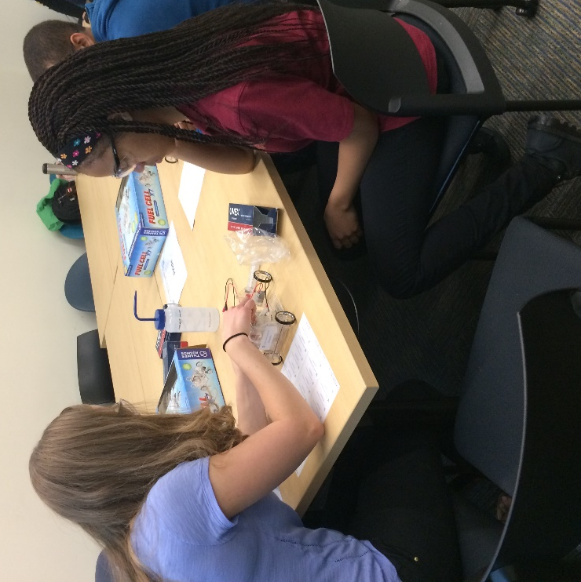
(Columbia Chemical Engineering Graduate Student teaches a student competitor about electrolysis.)

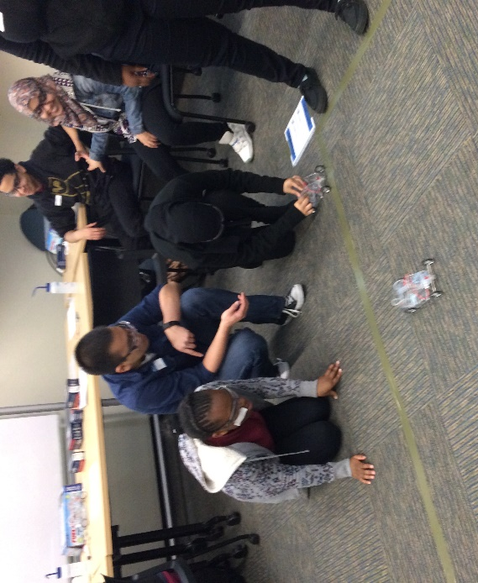
(Columbia Chemical Engineering Graduate Student guides the student team to the start line.)

Instructor Preparation and Rehearsals
A few meetings with graduate student leaders were needed prior to the event in order to inform graduate student leaders and to coordinate efforts. Prior to the event the instructor took time to teach the graduate student leaders about the safety and procedures for the competition. Instruction on safety, the basics of how the X7 Fuel Cell car works, the connection to the AIChE competition, the basic event timeline and resources required, connection to STEM outreach, back up plans, and troubleshooting were covered. A basic layout of the event space was drawn on a white board in order to help everyone understand the effect of the location of equipment, materials, and personnel. Plans were made for the graduate students to fill two larger containers with de-ionized water prior to the event. The smaller bottles were filled from the larger containers at the event site. The roles for each member of the teaching team were designated and a common operating picture was sketched out to make sure that everyone had the same idea of what the event site would look like and the role of each member on site for the day of the event.
ChemE Fuel Cell Car Competition
The initial stages of this event were led by the faculty member and graduate students involved with STEM outreach from ChEGO. The faculty member developed the instructional slides that covered safety, basic chemical engineering connections to the event, the event timeline, the operation of the X7 Fuel Cell Car, the fundamental chemistry and engineering concepts that support the competition, the rules for competition, and awards.[5-7] Prior to the event, the instructor reviewed all the slides with the graduate student leaders and demonstrated the use of the car as well as certain pitfalls. The graduate students had time to set up and rehearse with the cars prior to the students coming to the competition site.
A brief description of coverage of each area of the initial presentation follows: Safety was emphasized from the onset with instruction on risk assessment for the graduate student organizers prior to the event and for the participants on the day of the competition. All student participants were briefly introduced to the concept of frequency and consequences that make up risk. As the frequency of someone inadvertently getting water squirted in the eyes was determined to be a probable event and the consequences of such an event having possible lasting negative effects, a basic requirement for eye protection by all participants was developed and resourced for the event. Eye protection is maintained with the kit that was developed for use at Columbia or for use at an outreach location. The duration of the event was determined to be about an hour and a half. The host instructor started the event with a safety briefing and competition instructions using a computer projection system and power point slides. The students were broken down into teams by their teacher prior to coming so that the group would have a balanced and competitive atmosphere and so that there was no delay in getting into the activity upon arrival on site. During the introduction, the students were instructed on the connection to the AIChE Chemical Engineering Car Competition where college students build a car the size of a shoe box that can carry a specified load a given distance and stop within proximity of the finish line. The Columbia Chemical Engineering Demonstration and Competition uses a fully assembled Thames and Kosmos car and the stopping mechanism is the “limiting reactant”; the hydrogen gas used in the fuel cell of the car. It has also proved valuable to instruct the students on how to handle the Thames and Kosmos X7 Fuel Cell Car. From experience, students have a tendency to pick up the car from the fuel cell which is secured by friction, this can cause the car body to slip down and may cause water to be spilled as well as other damage when the student reacts and tries to grab the car. The wire connections are brittle and easily broken at the connection to the DC motor. There are a number of small parts that must be removed and re-installed from trial to trial. These parts may be easily lost and thus a rule for filling cars in single “filling station” location was established to help prevent loss and avoid clustering of groups near the start line. The competition zone was firmly established at the beginning of the event as this is the most common point of contention during the event. All student groups must start behind the tape that designated the start line. The finish line was marked with tape. No part of the car was to be over the finish line or past the finish line for a qualifying trial. The students were instructed on side boundaries as well.
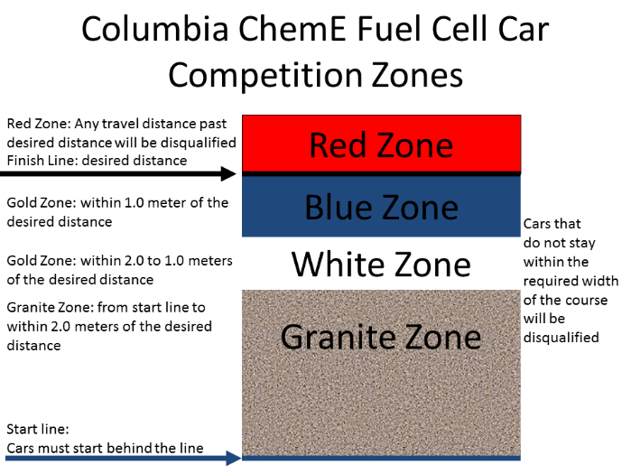
The department provided tape measures as awards for the student who won the competition and every student was presented with Columbia Chemical Engineering Rulers as a means of congratulating all for participating.
The competition day was set with instructors coming to the site about one hour prior to the student arrival. The room needed to be cleared of tables and chairs in order to set up the competition zone on the floor, the car filling station areas, and a computer connection to the screen projector. A square box outline was taped on the on the floor so that multiple competitive teams could run trials and so that the cars did not need to travel in a simply straight trajectory. As has been observed in the past with the X7 Fuel Cell Car, the wheels can get out of alignment and for an undetermined reason some student groups never overcome this challenge and seek to compensate otherwise. Each student group has a designated area as their filling station where the car, the distilled water bottle, and a group of three students and a graduate student instructor could work on electrolyzing the water in order to make the gas required to make the car go the distance desired. For other iterations of the competition, there have been instructors that manned given area, filling station area, the competitive zone, and perhaps the computer where the leader board may be updated. Depending on how much supervision the students need, the instructor can have more freedom to rove. As self-discovery may be desired a hands-off approach may be used, but the maturity level and self-discipline of the student must be a consideration for such an approach. Small DI water bottles were obtained so that each group could have their own source of water. Roughly 50 mL of water was used by each group during a competition so that water bottle per group is more than enough to get through the number of trials a student group will attempt. As each group runs a trial, a graduate student instructor tracks the progress and takes a measurement of the distance from the finish line. A leader board is maintained on the projection screen in order to highlight the shortest distance to the finish line.
For some iterations of the event, depending on the length of the competitive zone, there may be a desire to establish scoring zones with stickers as prizes to honor the student progress. This also helps encourage the competitive atmosphere. For the event held at Columbia, the distance was so short that zones were not established and the start, finish, and boundary lines were all that bounded the competitive zone. Toward the end of the competition, the student groups are given ample warning for when the time for trials will be concluded. Once end time has been called the student group with the closest finish is declared the overall winner and presented a prize, in this case, it was a tape measure with the Columbia Chemical Engineering logo on it.

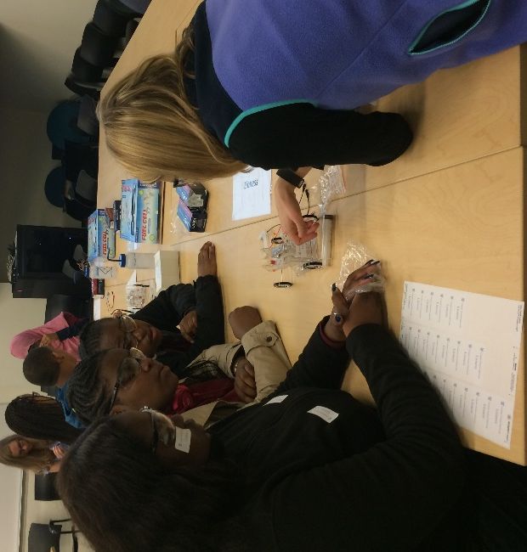
(Columbia Chemical Engineering Graduate Student teaches the competitors how the X7 Fuel Cell Car works.)
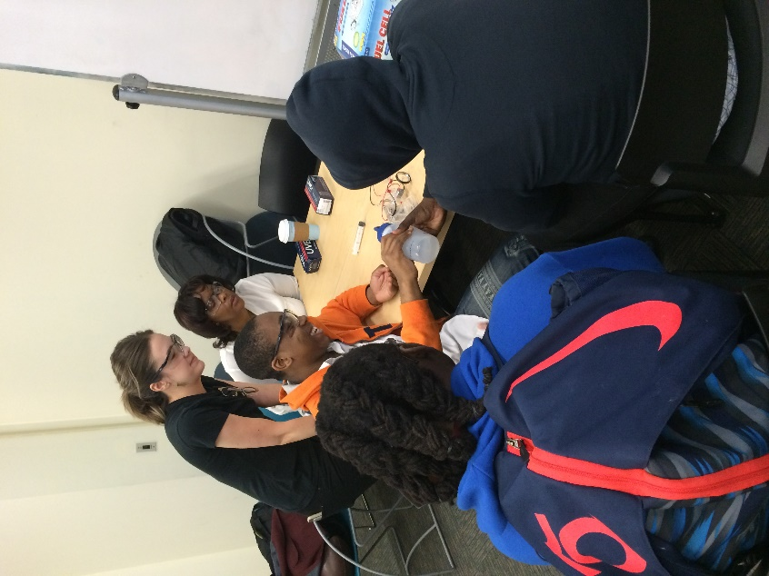
(Photo of “Filling Station” Operations)
Recovery Operations
All of the equipment was collected and placed into the rolling tool boxes at the end of the event for safe storage until the next use. Each car was drained of all water and subsequently checked for damages. Common damages include and possible solutions/uses follow:
Common Damage | Possible Solution
loss of the red stoppers for each hose | Buy more red stoppers from Thames and Kosmos
loss of the tips for the syringes | Sometimes you can cut a tip in half and just use a smaller tip, otherwise, buy more from Thames and Kosmos
breakage of the wire connections to the battery pack | Buy more battery packs from Thames and Kosmos
Breakage of the wire connections to the DC motor | Buy more DC motor front axle assemblies from Thames and Kosmos. While attempt may be made to repair the connections, it was deemed not worth the time for the quality of the repair. In some cases, there may be a desire to open up the motor in order to have a demonstration model available for students to see the inner workings of a DC Motor.
Breakage of the wheels, dry rot of the wheels | Buy more wheels from Thames and Kosmos
loss of conduction in the fuel cell | Buy more fuel cells from Thames and Kosmos

After Action Review
A quick follow up with the graduate student leaders and high school teacher was completed and it was determined that the event was a success. The amount of time spent on the event is driven by the complexity of the problem delivered to the student competitors. With the “speed racer” level of competition, the time to get to running trials is on the scale of minutes. The time for refilling is on the scales of minutes and based on the efficiency of the fuel cell, it only a takes a few seconds to electrolyze the DI water, thus about one hour to one and half hours is plenty of time to conduct a full competition. It is through the after action review process that changes and adjustments can be made for improvement of the experience.
Conclusion
The first Columbia Chemical Engineering Fuel Cell Car Demonstration and Competition was a safe and successful way to inspire and educate young people about chemical engineering with a hands-on experience modelled after the American Institute of Chemical Engineers (AIChE) ChemE Car Competition using the X7 Fuel Cell Car from Thames and Kosmos. [1, 2] This event has strong foundations with its connection to the AIChE Chemical Engineering Car Competition. The time required to execute this event was deemed not overly burdensome, and there are not large chemical hazards introduced that would otherwise raise the risk level of the event to an unreasonable level. The repairs and damages to the equipment are viewed as normal wear and tear, thus minor aspect of the event, but certainly one that requires preparation. The students expressed tremendous enthusiasm for the event and the instructors at all levels saw benefit from an event that exercises the chemical engineering problem solving approach on the time scales desired by the next generation of engineers.

Acknowledgements
This event would not have been possible without the support of the following Columbia Chemical Engineering Graduate Students: Ece Erturk, Emily Hsu, Gianna Credaroli, Thi Vo, Christianna Lininger, and Anna Dorfi. Administrative and logistical support was provided by Kathy Marte. Photographic support was provided by Ariel Sanchez.

Appendix 1

Description | Quantity | Unit Price | Amount | Remarks
X7 Fuel Cell Cars | 10 | $ 119.95 | $ 1,199.50 | Fuel Cell Store (at three people per car, this will service 30 students at one time. Add more cars for more students)  Use Coupon Code at Checkout for 15% OFF: DC15TX7
Fuel Cell X7 Battery Holder | 10 | $ 10.00 | $ 100.00 | Thames and Kosmos
Fuel Cell X7 Fuel Cell | 5 | $ 25.00 | $ 125.00 | Thames and Kosmos
Fuel Cell X7 Syringe | 10 | $ 2.50 | $ 25.00 | Thames and Kosmos
Fuel Cell X7 Bag of Small Part | 10 | $ 7.00 | $ 70.00 | Thames and Kosmos
DI Water Bottles | 10 | $ 7.75 | $ 77.50 | Amazon
Measuring tape | 2 | $ 9.24 | $ 18.48 | Amazon
550 cord (25 feet) for marking boundaries | 2 | $ 15.88 | $ 31.76 | Amazon
Tape (roll) for marking lines | 4 | $ 5.99 | $ 23.96 | Amazon
Eye protection: | 35 | $ 7.68 | $ 268.80 | Amazon
AA batteries (20 pack) | 3 | $ 16.99 | $ 50.97 | Amazon (batteries per charger + 50 overage) Duracell Coppertop AA Batteries, 20-Count
voltmeters | 10 | $ 29.99 | $ 299.90 | Radio shack
Poster printed and mounted on 56"x40" board | 2 | $ 50.00 | $ 100.00 | Kinko's
1-gallon water jugs for distilled water | 3 | $ 26.63 | $ 79.89 | U.S. Plastics
Rolling Tool Box, 21 x 20, Blk/Ylw | 2 | $ 87.00 | $ 174.00 | www.zoro.com
subtotal |  |  | $ 2,644.76

Works Cited
1. Unknown. Chem-E Car Competition Award. 2016 [cited 2016; Available from: http://www.aiche.org/community/awards/chem-e-car-competitionr-award.
2. Unknown. Fuel Cell X7 Hydrogen Powered Car. 2016 [cited 2016; Available from: http://www.thamesandkosmos.com/index.php/product/category/science-kits/fuel-cell-x7.
3. Bozic, R.G., Bringing Chemical Engineering to the Masses through a Fuel Cell Car Demo and Competition, in AIChE Annual Meeting Conference Proceedings, 2012. 2012.
4. Unknown. Avery® Easy Peel® White Address Labels for Laser Printers 5160. 2016 [cited 2016; Available from: http://www.avery.com/avery/en_us/Products/Labels/Addressing-Labels/Easy-Peel-White-Address-Labels_05160.htm?N=0&Ns=&refchannel=c042fd03ab30a110VgnVCM1000002118140aRCRD.
5. West, A.C., Electrochemistry and Electrochemical Engineering: An Introduction. 2012: CreateSpace Independent Publishing Platform.
6. Prentice, G., Electrochemical Engineering Principles. 1991: Prentice Hall.
7. Silberberg, M., Chemistry: The Molecular Nature of Matter and Change. 2006: McGraw-Hill.

